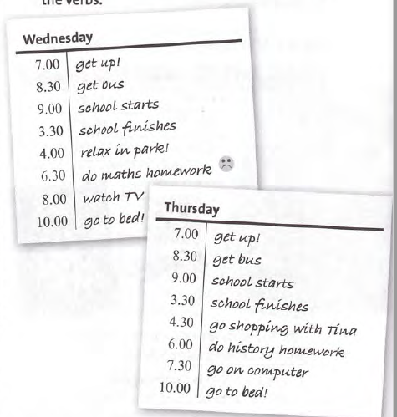

6/3 Complete the text:

My sister gets up at 7 a.m. and she _________ the bus to school at 8.30 a.m.
School ________________ at 9 a.m. and it finishes at 3.30 p.m. After school on Wednesdays, she ____________ with her friends. On Thursdays, she _________ shopping in town. In the evening, she___________________ her homework
and then she ________________ TV or goes on the computer and chats with her friends. She ______________ to bed at 10 p.m.

7/3 Present simple and present continuous
Complete the phone conversation. Use
the present simple or the present continuous
form of the verbs in brackets.
Mum Hi, Ollie. It's Mum. I'm coming (come) home now.
Ollie OK, Mum.
Mum 1________________ (you / study) for your important exam?
Ollie No, I _________________ (chat) to Sirr:lOn.
We 3 ________________ (talk) about the exam.
Mum But you 4 ______________ (talk) to him every day.
Ollie No, we 5 __________________ (not chat) in class. We 6__________ (listen) to our teacher.
Mum Are you sure? What 7 ________________ (your sister / do) at the moment?
8 ________________________(she / do) her homework?
Ollie No, of course not, Mum. She never ___________________9 (do) her homework. She __________________10 (watch) TV, I think!

